Lab 13

**Configure VPC Peering Between two VPC’s – 1 of 3**

**Scenario:**

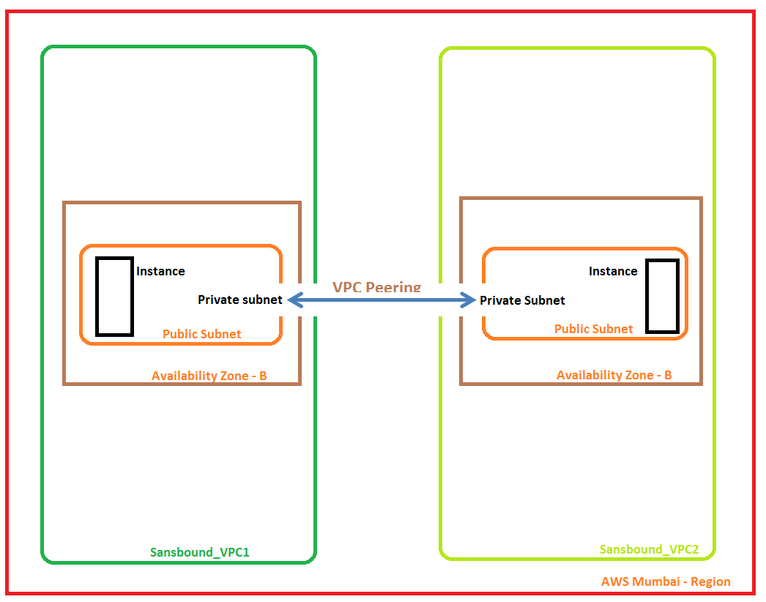

By default same regions VPC’s are not communicate, hence we have required to configure VPC Peering for that.

Got to VPC Dashboard,

Click “Create VPC”

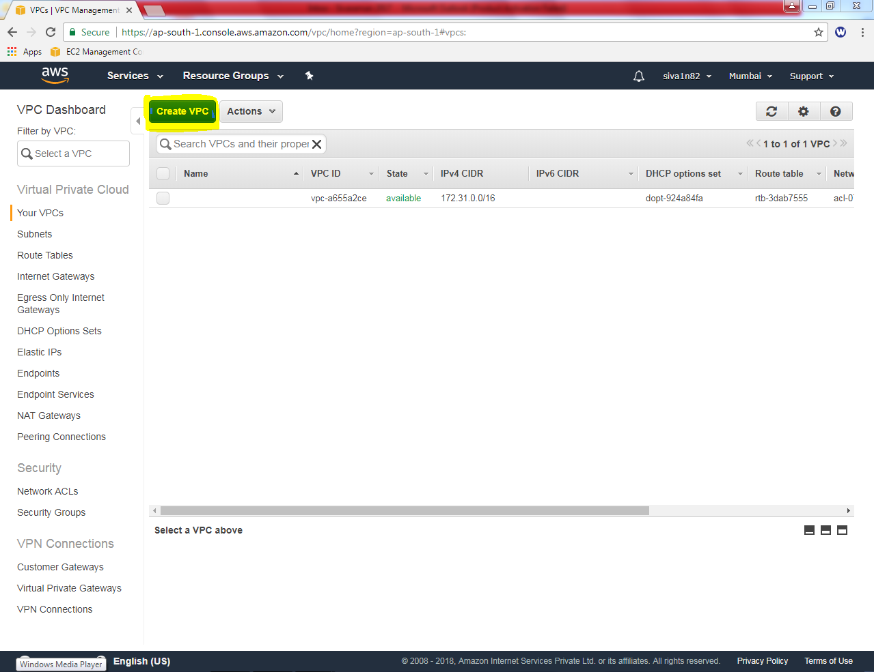

While creating VPC, Name tag “Sansbound_VPC1”

IPV4 CIDR block as 10.0.0.0/16 subnet.

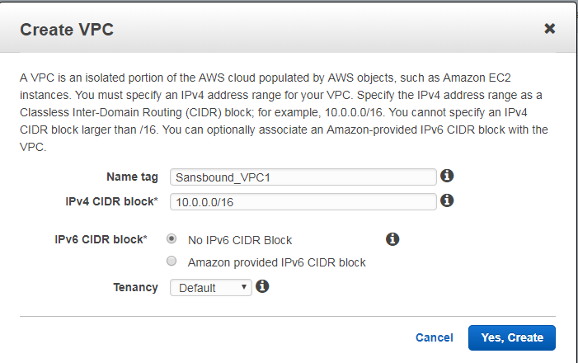

Then click “Yes, create”.

Then we need to create subnet for the Sansbound_VPC1.

In VPC Dashboard, click Subnet, then click “create subnet”.

While creating subnet,

Name tag as “Sansbound_VPC1_Public_Subnet”.

VPC as Sansbound_VPC1.

Availability Zone – 1B (Optional)

IPv4 CIDR Block – 10.0.2.0/24 subnet.

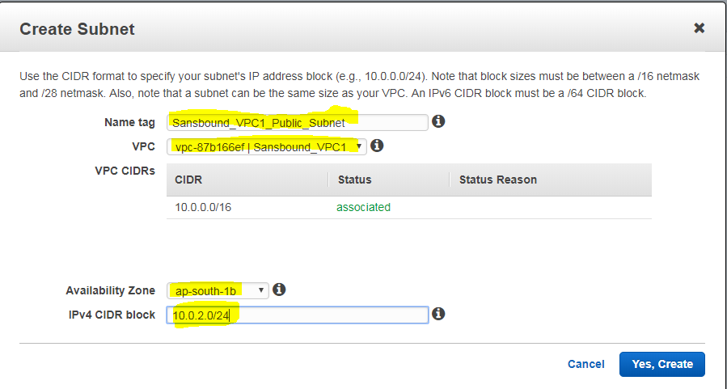

Then Click “Yes, create”.

Then we need to create an internet gateway, click “create Internet Gateway”.

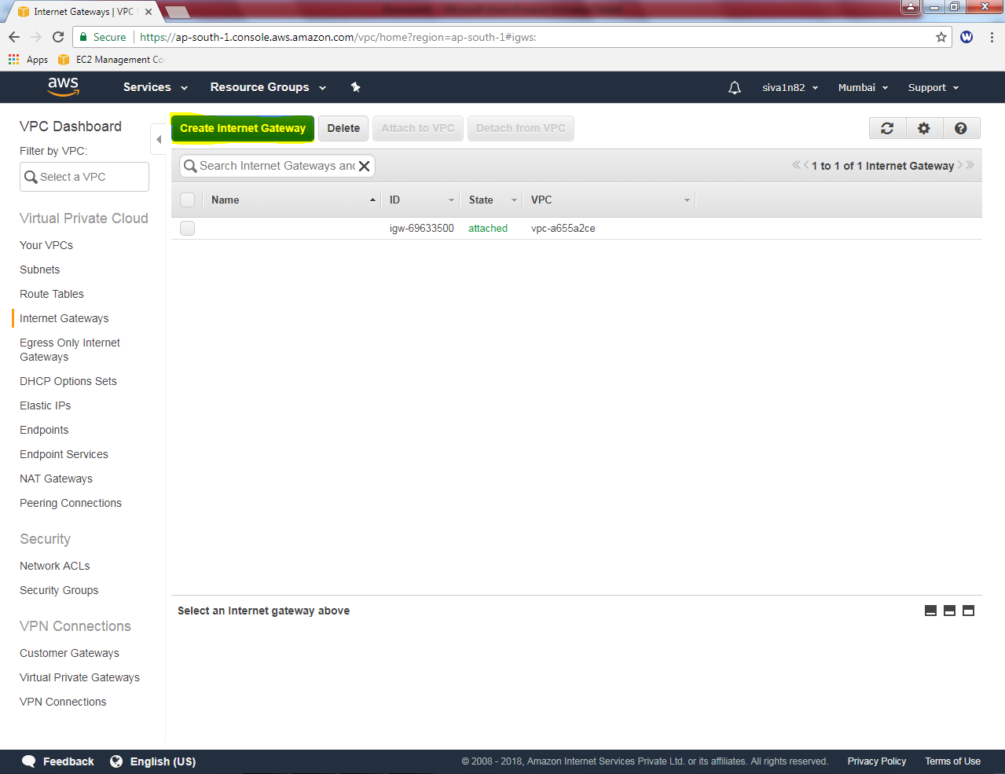

While creating internet gateway Name tag as “Sansbound_VPC1_IGW”.

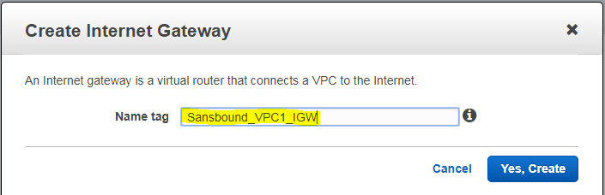

It shows, IGW in detached state, we need to attach VPC.

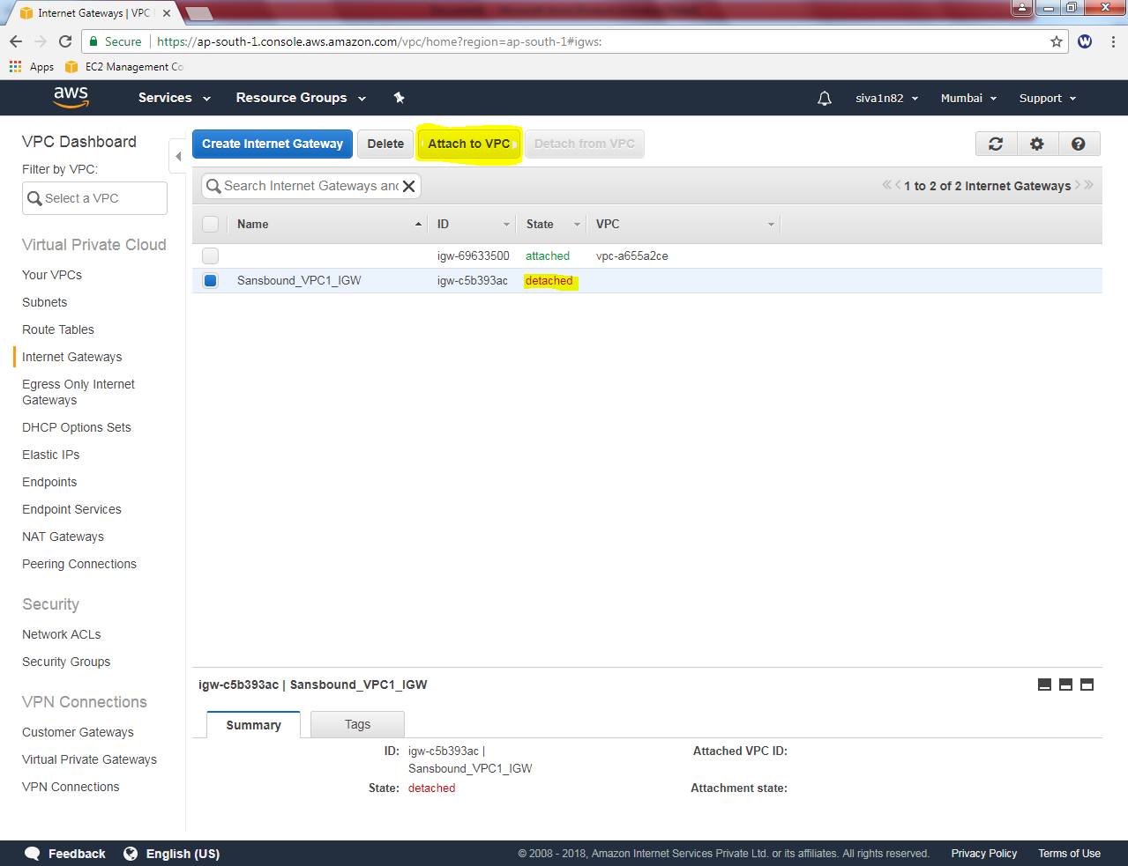

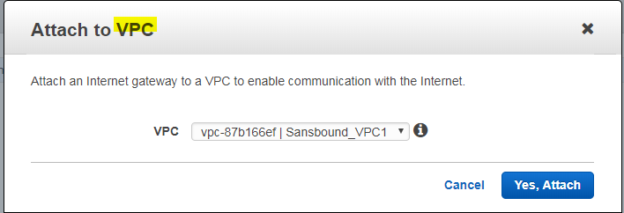

Click “Yes, Attach”.

Rename the Sansbound_VPC1 route table as sansbound-public_route.

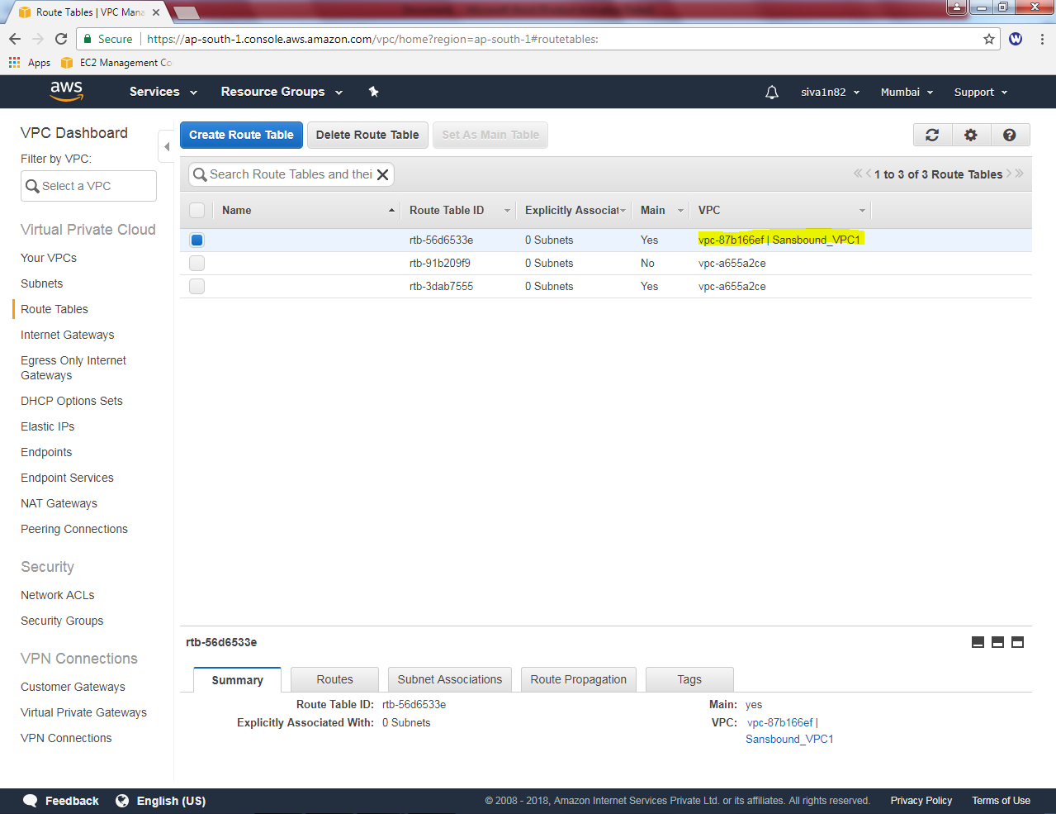

In Sanbound_Public_route table, select route tab then click “Edit” option.

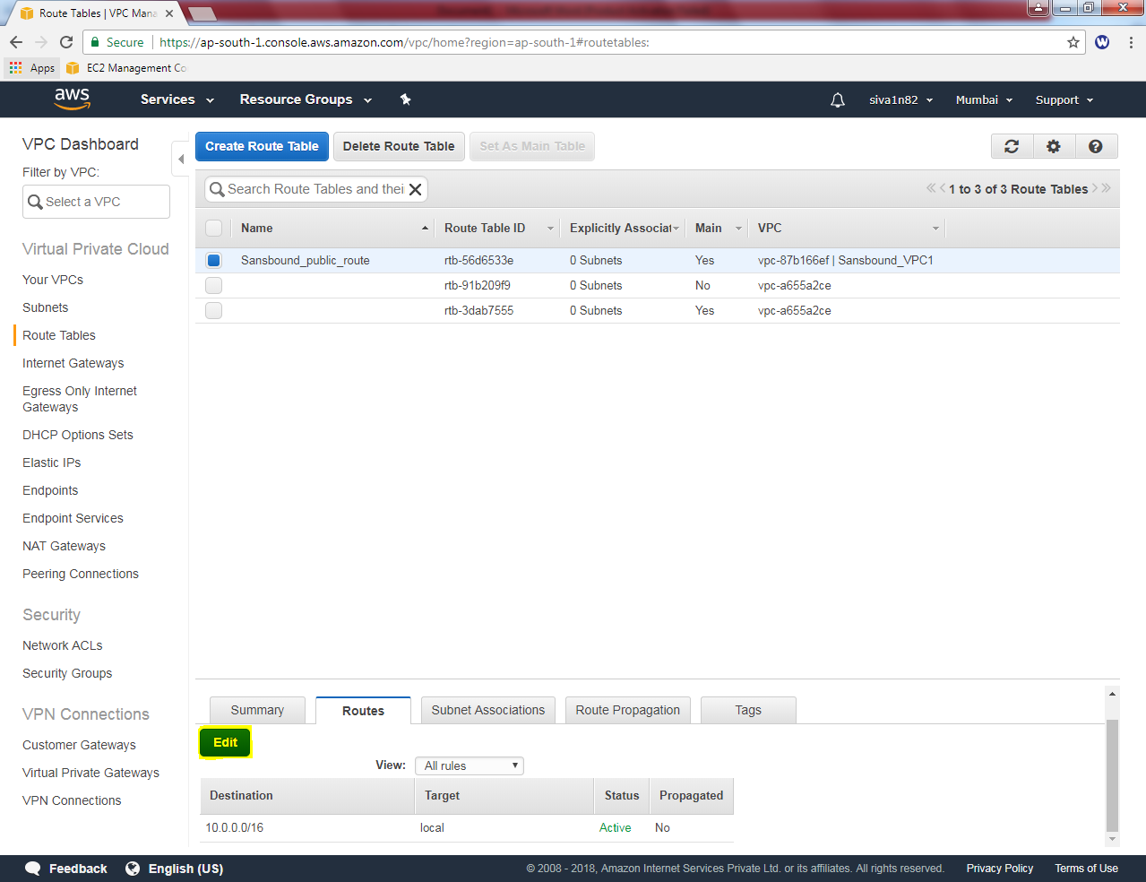

Click “Add another route” button.

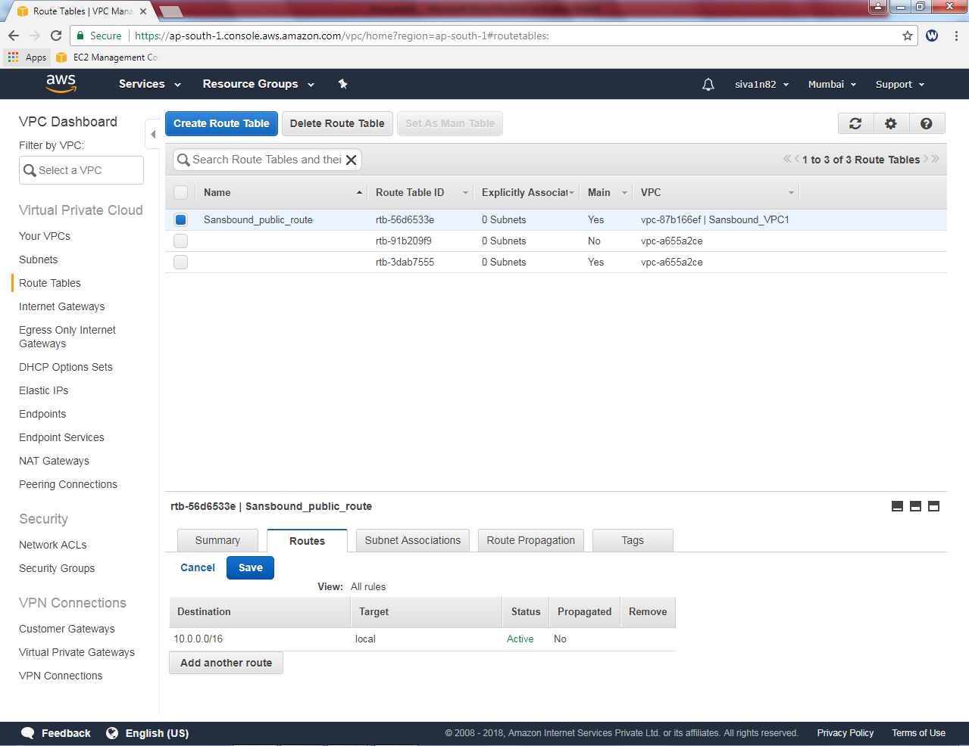

Add default route 0.0.0.0/0 and select **”igw-*”** as target.

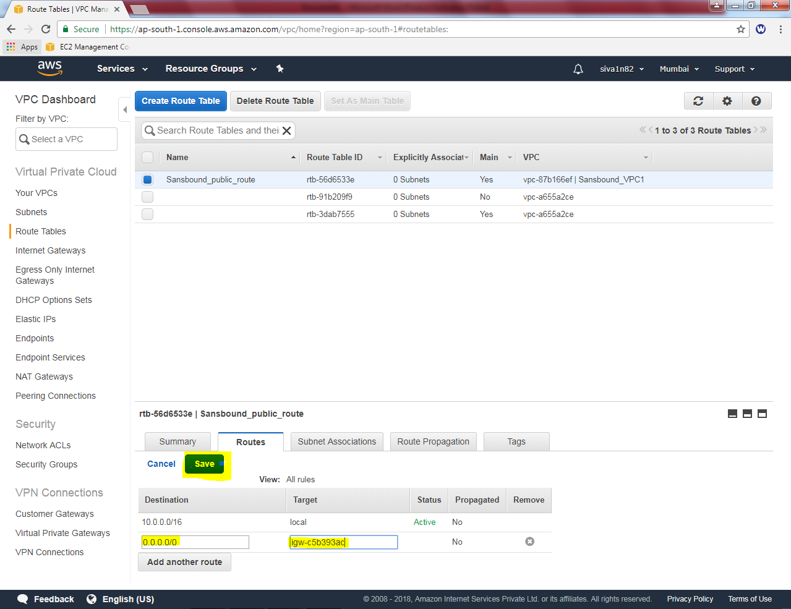

Then click “save”.

Then we need to associate the subnet. Click “Subnet associations” tab, then click “Edit” option.

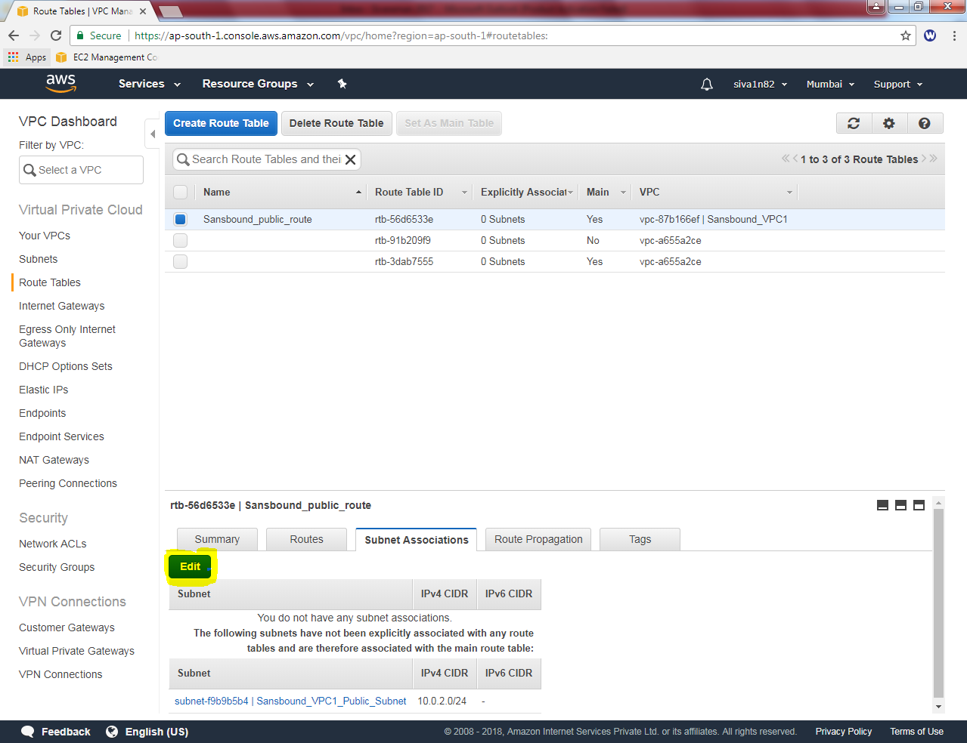

Select option check box option to select “sansbound_VPC1_Public_subnet”.

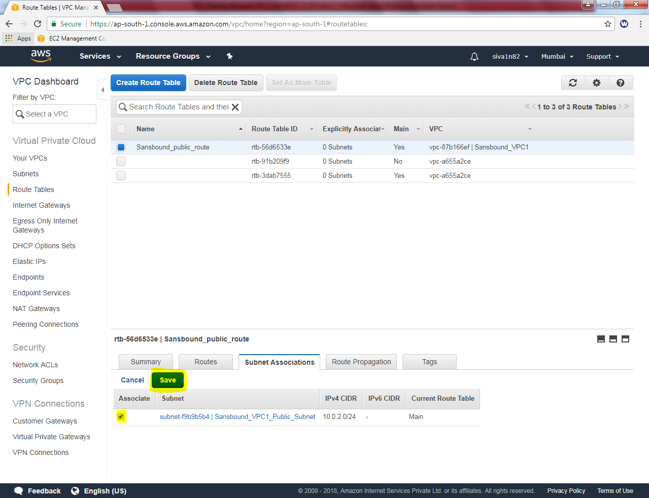

Then click “Save”.

Then we need to create an instance for VPC1. Click “Launch Instance”.

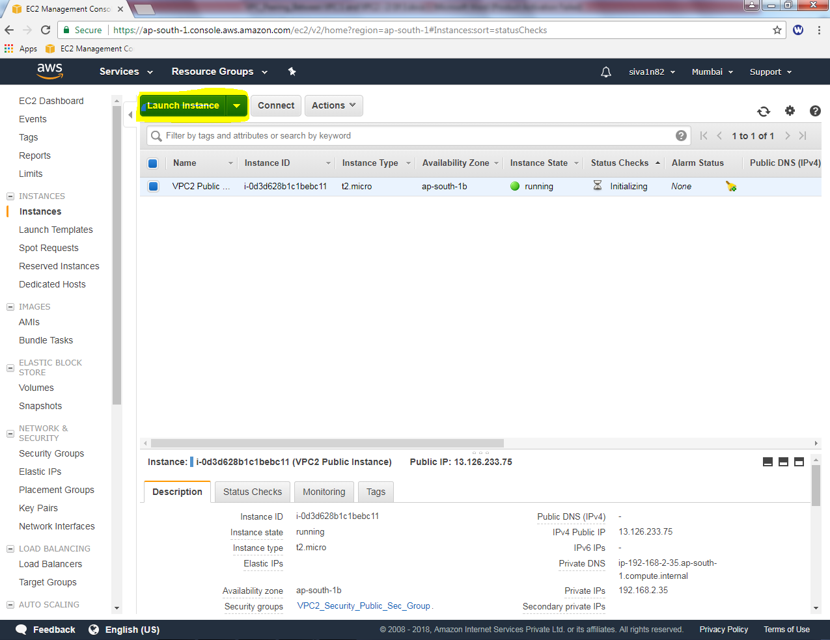

Select “Microsoft Windows server 2016 Base”option.

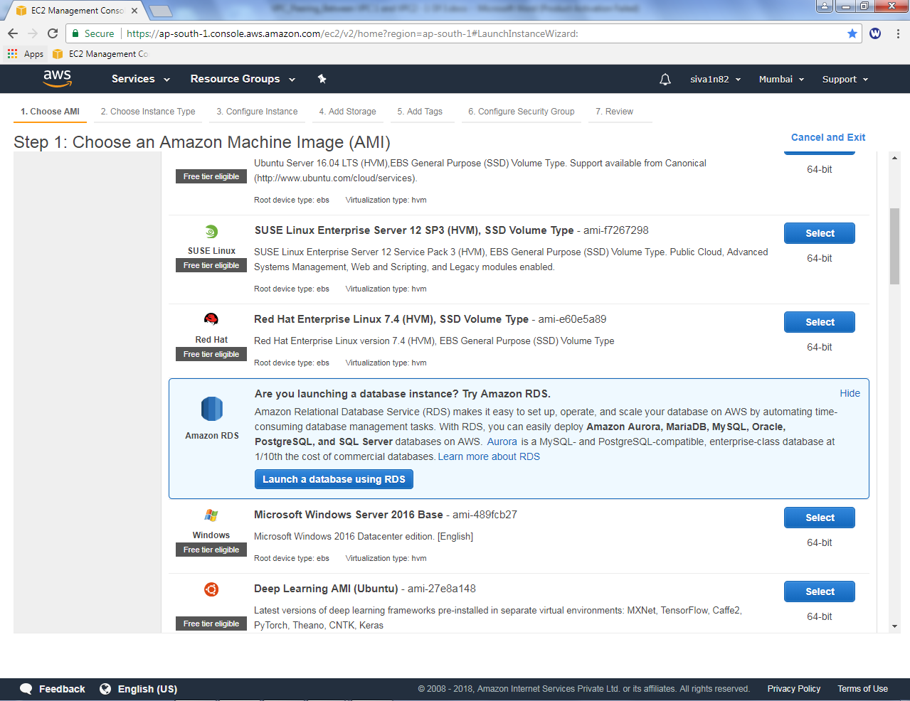

Select “t2 micro”

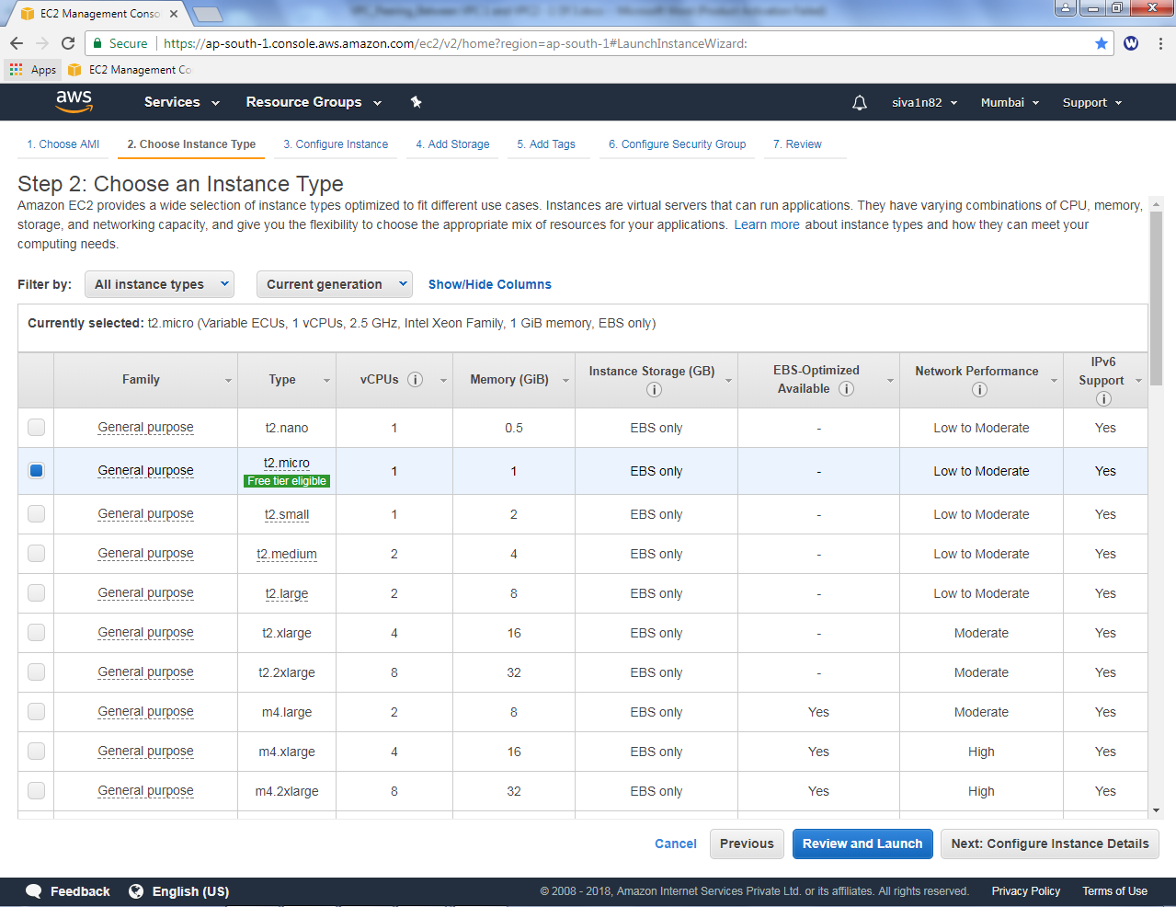

Click “Next”.

Select Network as Sansbound_VPC1

Subnet : Sansbound_VPC1_public_Subnet

Auto Assign Public IP: Enable.

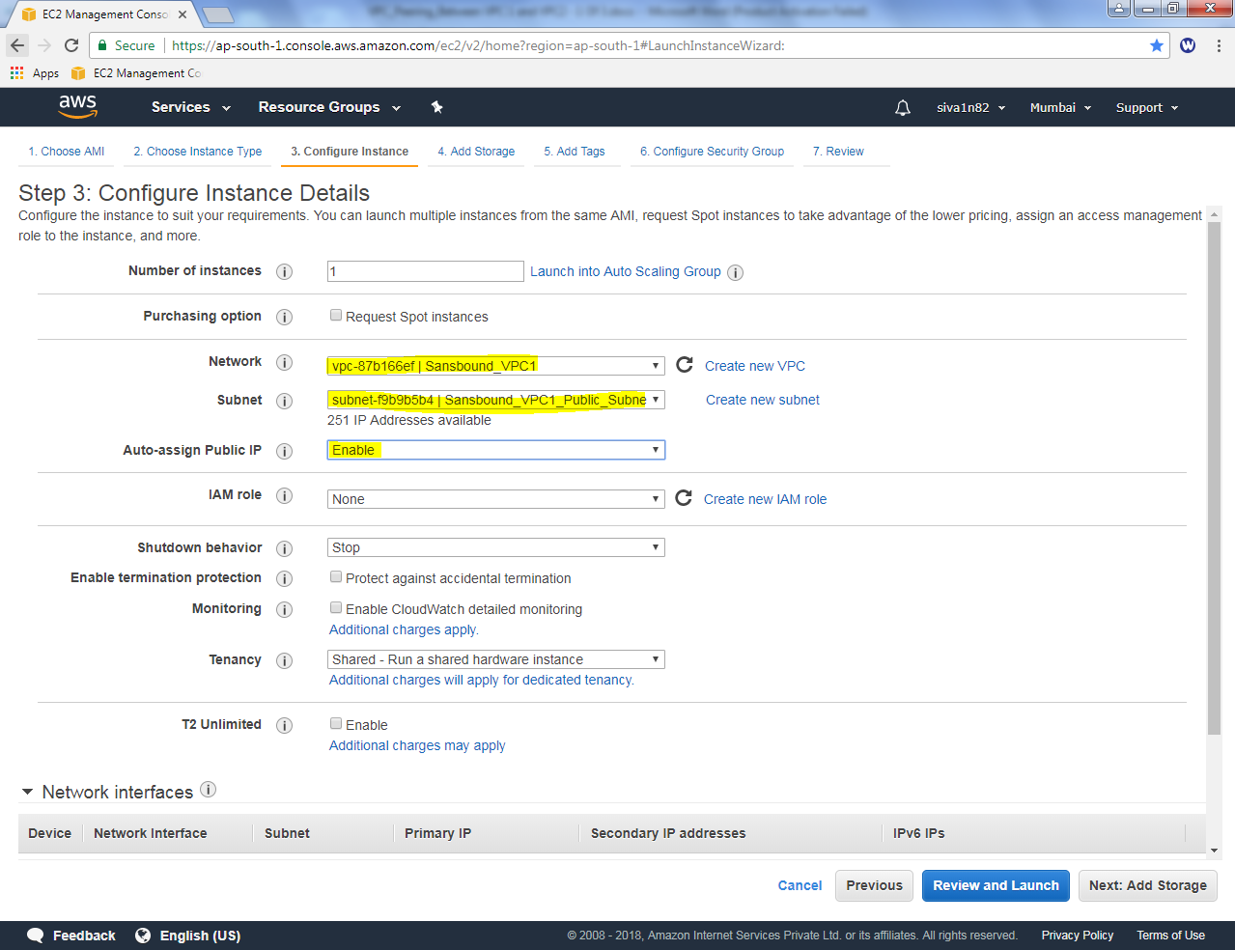

Click “Next”.

Leave default and click “Next”.

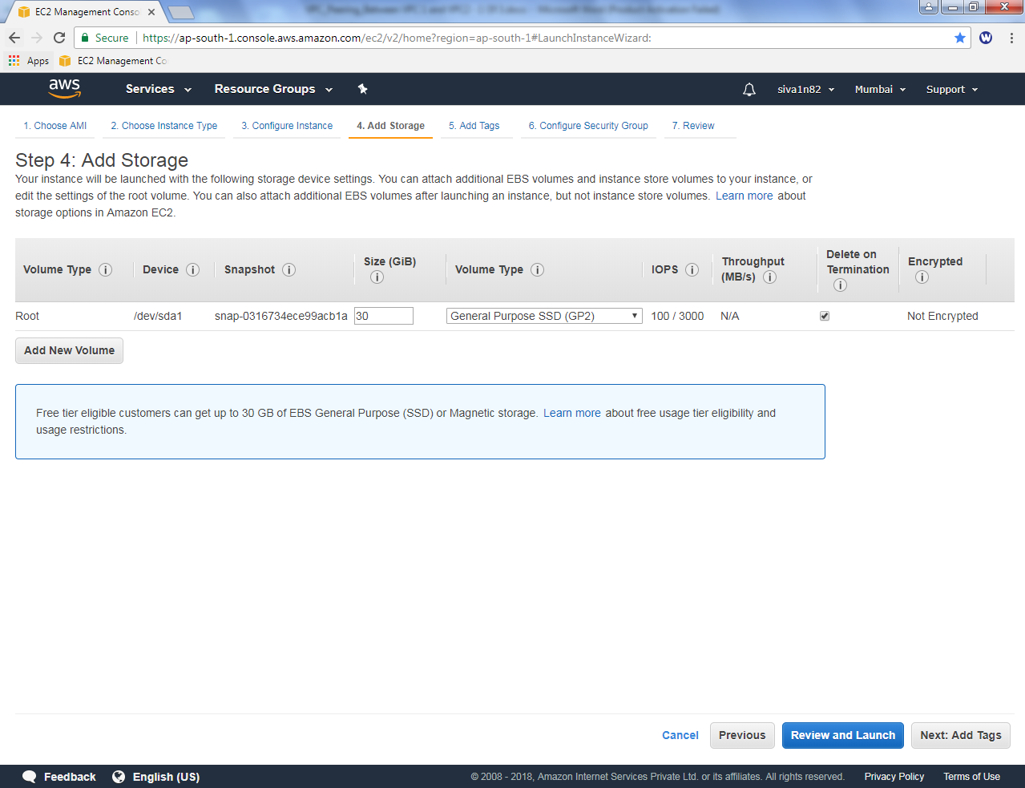

Name: VPC1 Public Instance

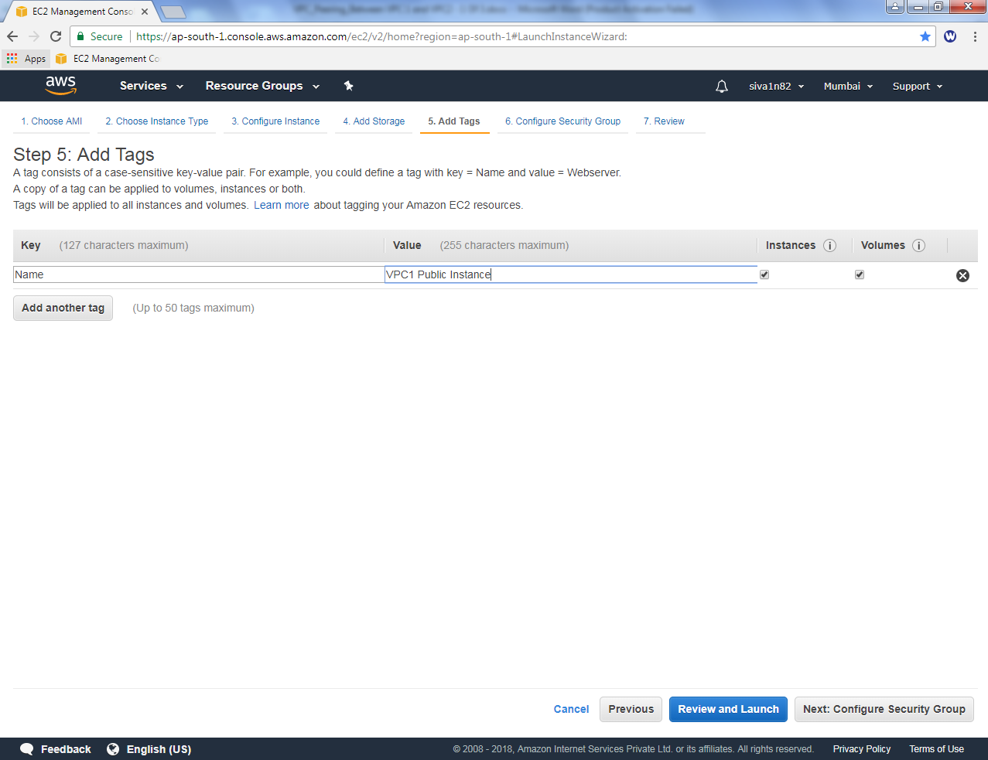

Click “Next”.

Create a new security group for VPC1, as VPC1_Public_Sec_Group.

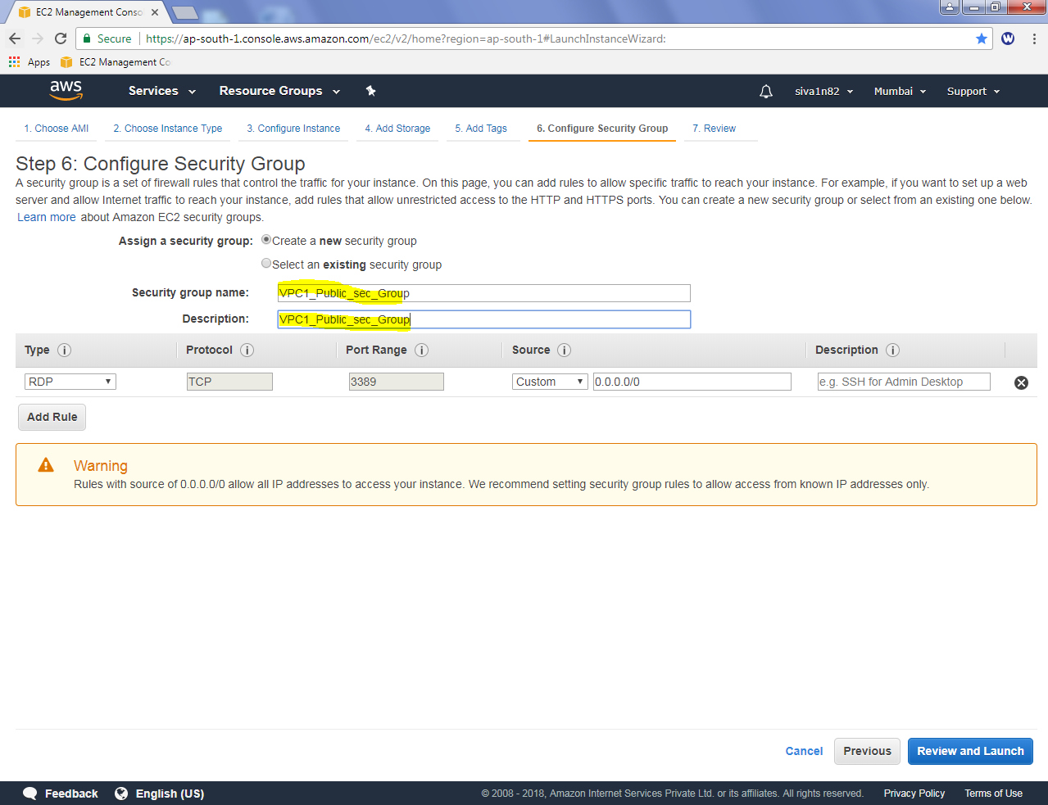

Click “Review and Launch”.

Select the keypair the launch the machine.

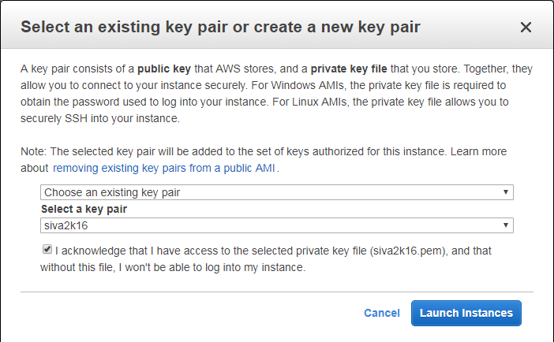

Click launch instance to run the machine.